CS 320 Project

Password Manager

# Sequence Diagram

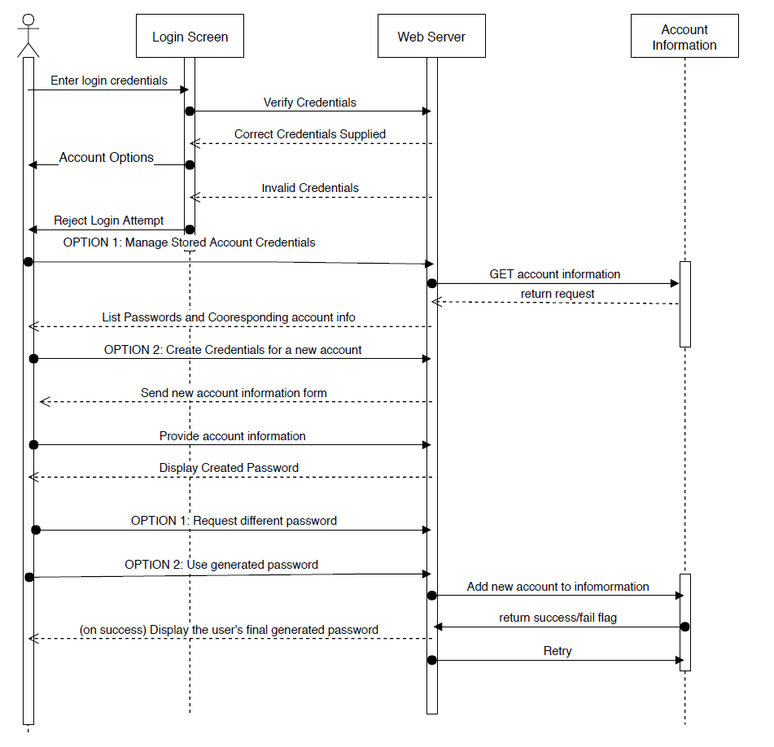

# Swimlane Diagram

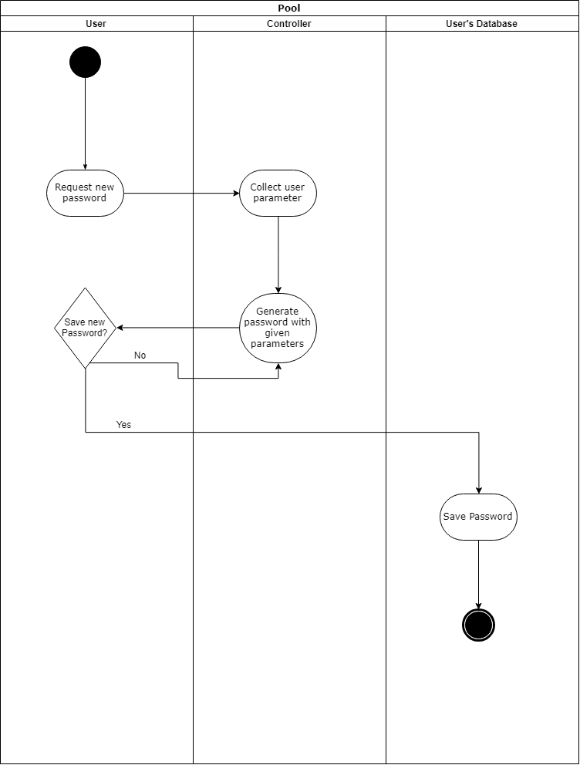

# Use Case Diagram

